**Instructions for Capstone Project 1 - Online Resume**

Project Specifications

1. Create an HTML file named **index.html**.
2. Use the **<!DOCTYPE html>** declaration at the beginning of the file to indicate that it's an HTML document.
3. Create a **head** section that includes a **title** element with the text "**My Resume**".
4. Inside the **body** section, write HTML code to create an online resume covering the following aspects:
   * **Summary** or objective statement
   * **Education** (list degrees, schools, and dates)
   * **Work experience**(list job titles, employers, dates, and responsibilities)
   * **Skills** (list relevant skills or areas of expertise)
   * Awards, certifications, or other achievements (list any relevant awards, certifications, or other accomplishments)
5. Use appropriate HTML tags to format the content of each section, such as **h1** for section headings and **ul** or **ol** for lists.
6. Use HTML tags to add a **profile photo**of yourself.
7. Use relevant anchor tags to create a multi-page website, listing other aspects of your resume such as **Hobbies** and **Contact** details.
8. Add a **footer** element with your name and any copyright information or other disclaimers. (Hint: use the MDN docs for things you don't know how to do: <https://developer.mozilla.org/en-US/docs/Web/HTML/Element/footer>
9. Save the **index.html** file and open it in a web browser to ensure that it displays correctly.
10. Add your website to your GitHub to start building your portfolio.
11. Publish your website using GitHub pages and share it here (in the Q&A) with other students.
12. Comment and make suggestions to other students' projects.

Example

<https://appbrewery.github.io/capstone-1-example>

**Container:**

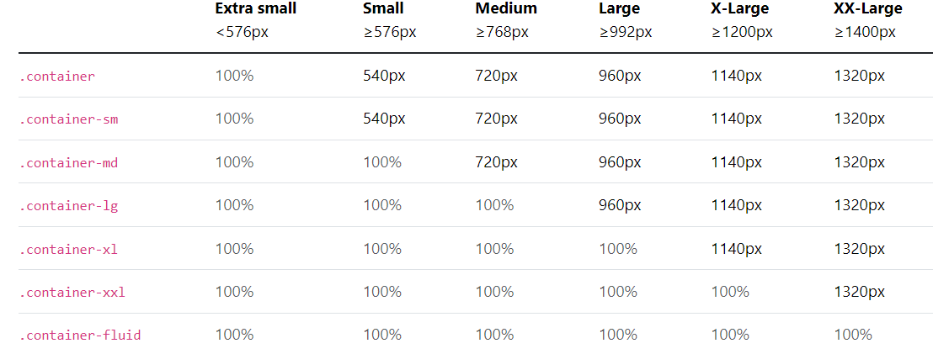

**Breakpoints:**

